A PBL report on
COURSE REGISTRATION SYSTEM
By
Sahil Doijad
Nikhil Dubey
Divij Gangavane
Rushikesh Bhosale


Department of Engineering Science and Humanities
Marathwada Mitra Mandal’s
College of
Engineering,
Karvenagar, Pune
[Sem-I, A.Y. 2025-
26]
Marathwada Mitra Mandal’s
College of Engineering,
Karvenagar, Pune
C E R T I F I C A T E
This is to certify that Sahil Doijad(B25IT1087), Nikhil Dubey
(B25IT1089), Divij Gangavane (B25IT1093), Rushikesh Bhosale
(B25IT1080) have completed the PBL Project entitled -“………………………
………...” under my supervision, in the partial fulfilment of First Year Engineering of Savitribai Phule Pune University.
Date :
Place :
Guide‘s Name
Dr. A.S. Sawaikar
Head
Principal
DESH MMCOE, Pune
MMCOE, Pune

ACKNOWLEDGEMENT (14 pts, Bold)
(12 pts)We take this opportunity here to thank all those who have helped us in
making this PBL project a reality.
First of all, we express our deep gratitude to our project guide, Prof., for his valuable support, help & guidance from time to time during the project work. We are also grateful to our Head of Department, Dr A.S. Sawaikar, for giving us this opportunity to present this project report.
Last but not least, we would like to thank our entire teaching and Non-teaching staff who assisted us directly or indirectly throughout the duration of this project.
Name of Student PRN
- Sahil Doijad B25IT1087
- Nikhil Dubey B25IT1089
- Divij Gangavane B25IT1093
- Rushikesh Bhosale B25IT1080

INDEX (14 pts., Bold) for reference only
Ch. No. Certificate Page No.
Acknowledgments
Index
List of Figures List of Tables
Nomenclature ^{vi}

1 Introduction ¹
1.1 Background of the Problem 1
1.2 About the Project 2
1.3 Objectives 3
1.4 Scope of the Project 5
- Literature Review & Research 6
  - Review of Existing Similar Programs 6
  - Research on Techniques / Methods ⁸
  - Summary of Findings 8
  - How This Project is Different / Innovative
- Problem Definition & Requirements 9
  - Problem Statement 9
  - Motivation for Selecting the Problem 14
  - Project Features 16
  - Requirements of the Project
    - Hardware Requirements
    - Software Requirements
  - Hardware Requirements
  - Software Requirements
  - Expected Output
- Methodology 18
  - Introduction 18
  - System Architecture
  - Algorithm of the Program 18
  - Flowchart of the Program 18
  - Explanation of Logic Used 21
- Implementation in C Language 21
  - Sample Input and Output 21
  - C Concepts Used in the Program 22
  - Program Flow / Stepwise Execution
  - Data Structures Used
  - Challenges / Issues Faced
  - Testing
  - Test cases used
- Innovative Techniques / Enhancements 23
  - Any New Feature Added
  - Efficiency Improvements / Optimisations
  - User Interface / Ease of Use Enhancements
- Results and Discussion
  - Output Screens
  - Result Discussion
- Conclusion
  - Conclusion
  - Limitations
  - Future Improvements
- Project Links / References
  - GitHub Repository Link (Code)
  - Project Demo Video Link (YouTube / Recorded Demo)
  - Blog or Tutorial Link (If any)
  - References (Books, Websites, Articles)

LIST OF FIGURES
Figure No. Title of Figure Page No

1.1 | Basic System Overview Diagram | 7
1.2 | Block Diagram of Course Registration System | 8
2.1 | Comparison of Manual vs Automated Registration (Chart) | 12
3.1 | Use Case Diagram for Course Registration System | 15
3.2 | Entity-Relationship Representation of Data (Courses–Students) | 17
4.1 | System Architecture (Input–Process–Output Model) | 19
4.2 | Flowchart of Student Registration Process | 20
4.3 | Flowchart of Course Addition Module | 21
4.4 | Flowchart of Attendance & Marks Module | 22
5.1 | Screenshot: Main Menu of Program | 25
5.2 | Screenshot: Add Course Screen | 26
5.3 | Screenshot: Add Student Screen | 27
5.4 | Screenshot: Register Student to Course Screen | 28
5.5 | Screenshot: Display Course Details Output | 29
5.6 | Screenshot: Attendance & Marks Entry Output | 30
6.1 | Improved Output Format (Enhanced UI Concept) | 31
7.1 | Final Output Summary Display | 33

LIST OF TABLES
Table No Title of Table Page No.
1.1 | Comparison of Existing Systems and Proposed System | 9

3.1 | Hardware Requirements for the System | 13

3.2 | Software Requirements for the System | 14

3.3 | Functional Requirements of the Course Registration System | 16

3.4 | Non-Functional Requirements (Performance, Reliability, etc.) | 17

3.5 | Course Data Structure Format | 18

3.6 | Student Data Structure Format | 19

5.1 | Sample Course Input Data | 23

5.2 | Sample Student Input Data | 24

5.3 | Mapping of C Concepts to Program Modules | 25

5.4 | Sample Output – Registered Students | 26

5.5 | Sample Output – Courses and Available Seats | 27

5.6 | Test Cases Used for Validation | 32

7.1 | Summary of Results Obtained | 34

NOMENCLATURE (14 pts., Bold) for reference only
Symbol Meaning
Greek Symbols

ABSTRACT
Keywords-
This project presents a simple Course Registration System, implemented in C language, which allows the registration of students, viewing of all registered students, and searching for a student using their ID.
The program uses structures, arrays, and decision-making constructs. It is menu-driven and suitable for basic data handling in an academic environment.
Keywords: C Programming, Structure, Course Registration, Student Management

- Introduction
  - Background of the Problem
Manual course registration often leads to errors and difficulty in maintaining records. A computer-based system improves accuracy and reduces effort.
1.2 About the Project
The developed C program allows:
- Registering students
- Displaying all registered students
- Searching for a student by ID
The system stores data temporarily during runtime using an array of structure objects.
1.3 Objectives
- To create a simple student registration platform.
- To store student details in a structured format.
- To enable easy searching and viewing of records.
- To demonstrate the practical working of structures and arrays.
1.4 Scope of the Project
- Useful for small-scale educational applications
- Demonstrates essential concepts of C programming
- Can be expanded into a full course management system

- Literature Review
2.1 Review of Existing Systems
Many systems use GUI and databases, but beginner-level programs use structures and arrays to understand logic building.
2.2 Techniques Used
Your code uses:
Structures to group student data
Arrays to store multiple student entries
Loops for iteration
if-else for decision making
scanf for input
Menu-driven programming
2.3 Summary of Findings
Simple menu-based programs are ideal for learning the fundamentals of storing, retrieving, and searching data.

3. Problem Definition & Requirements
3.1 Problem Statement
- To design a C program that registers students with ID, Name, and Course, and allows viewing and searching.
3.2 Motivation
- To reduce effort in maintaining basic student registration records and to create a foundation for advanced systems.
3.5 Features of the Program
- Register student
- Display all students
- Search by student ID
- Exit menu option
3.4 Requirements
- Hardware Requirements
- A computer/laptop
- Minimum 2GB RAM
- C compiler support
- Software Requirements
- Windows/Linux OS
- GCC/Turbo C compiler
- Code editor (VS Code / CodeBlocks)
3.5 Expected Output
- Student successfully registered
- Student list displayed
- Student found/not found

4. Methodology
4.1 System Architecture (Simple)
User → Menu → Structure Array → Output on Screen
4.2 Algorithm
- Start
- Display menu
- If the user selects register → input data
- If view → display array content
- If search → match ID
- If exit → terminate
- Stop
4.3 Flowchart

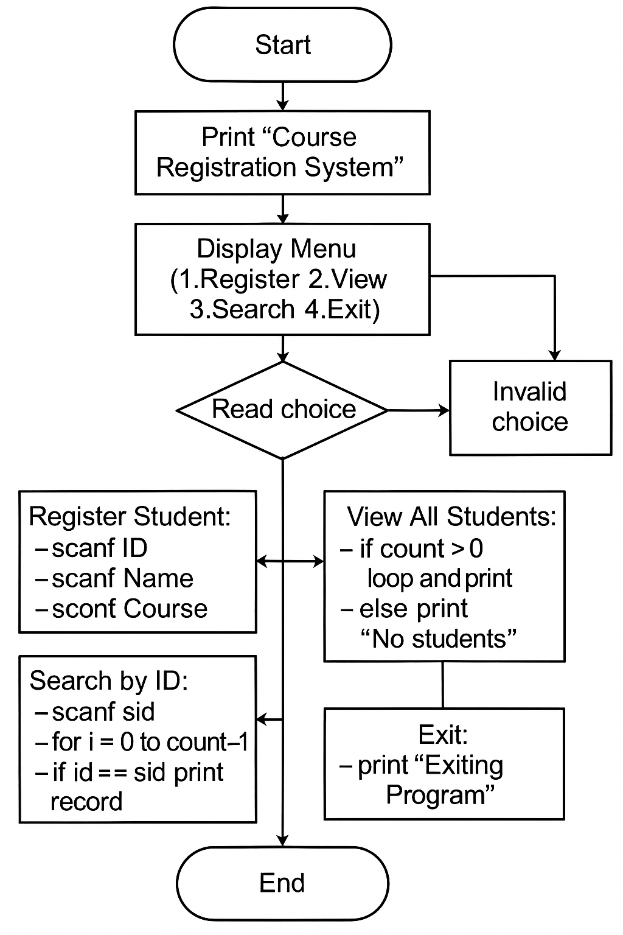
4.4 Logic Used
- Structure holds: ID, Name, Course
- Array stores 50 student records
- count variable tracks total students
- Linear search used for finding ID

5. Implementation in C Language
5.1 Source Code
#include <stdio.h>
#include <string.h>

struct Student {
int id;
char name[50];
char course[50];
};

int main() {
struct Student s[50];
int choice, count = 0, i;

printf("===== Course Registration System =====\n");

while (1) {
printf("\n1. Register Student");
printf("\n2. View All Students");
printf("\n3. Search Student by ID");
printf("\n4. Exit");
printf("\nEnter your choice: ");
scanf("%d", &choice);

if (choice == 1) {
printf("\nEnter Student ID: ");
scanf("%d", &s[count].id);
printf("Enter Student Name: ");
scanf(" %[^\n]", s[count].name);
printf("Enter Course Name: ");
scanf(" %[^\n]", s[count].course);
count++;
printf("Student Registered Successfully!\n");
}
else if (choice == 2) {
printf("\n--- Registered Students ---\n");
for (i = 0; i < count; i++) {
printf("ID: %d | Name: %s | Course: %s\n", s[i].id, s[i].name, s[i].course);
}
if (count == 0)
printf("No students registered yet.\n");
}
else if (choice == 3) {
int sid, found = 0;
printf("\nEnter Student ID to Search: ");
scanf("%d", &sid);
for (i = 0; i < count; i++) {
if (s[i].id == sid) {
printf("ID: %d | Name: %s | Course: %s\n", s[i].id, s[i].name, s[i].course);
found = 1;
break;
}
}
if (!found)
printf("Student not found.\n");
}
else if (choice == 4) {
printf("Exiting Program. Thank You!\n");
break;
}
else {
printf("Invalid choice! Please try again.\n");
}
}
return 0;
}

5.2 C Concepts Used
- Structure
- Arrays
- Loop
- Conditionals
- String handling
- Menu-based input
5.3 Sample Input/Output
Input:
1
ID: 101
Name: Rahul
Course: C Programming
Output:
Student Registered Successfully!
5.4 Data Structures Used
struct Student {
int id;
char name[50];
char course[50];
};
5.5 Challenges Faced
- Handling spaces in names
- Tracking the number of students
- Searching within an array

5.6 Testing
Tested with multiple students and searches.
4 ss

6. Innovative Techniques / Enhancements
- Use of structure for grouping data
- String input with spaces
- Menu-driven modular design

7. Results and Discussion
7.1 Output Screens
- Student registration
- View all students
- Searching student by ID
(I can generate screenshots if needed) 4ss
7.2 Discussion
The program meets the required objectives: storing, viewing, and searching student records.

8. Conclusion
8.1 Conclusion
The Course Registration System successfully demonstrates structure-based data handling in C.
8.2 Limitations
- No file storage
- Maximum of 50 students only
- No update/delete functionality
8.3 Future Improvements
- Add file handling
- Add attendance/marks
- Add update/delete feature
- Convert into a web or GUI system

- Project Links / References
9.1 GitHub Repository Link (Code)
- [GitHub Repo] — (Add your repo link here)
9.2 Project Demo Video Link
- (Upload demo video to YouTube and paste link here)
9.3 Blog or Tutorial Link
- (Optional — add if available)
9.4 References (Books, Websites, Articles)
- K. N. King, C Programming: A Modern Approach.
- TutorialsPoint — File Handling in C.
- GeeksforGeeks — Structures in C, File I/O in C.

References
- Course format used from PBL Sample Report (uploaded).
PBL Sample Report Format (1)
- K. N. King — C Programming: A Modern Approach
- GeeksforGeeks and TutorialsPoint articles on File I/O and Structures in C

References
- S. M. Metev and V. P. Veiko, Laser Assisted Microtechnology, 2nd ed., R. M.
Osgood, Jr., Ed. Berlin, Germany: Springer-Verlag, 1998.
- J. Breckling, Ed., The Analysis of Directional Time Series: Applications to Wind Speed and Direction, ser. Lecture Notes in Statistics. Berlin, Germany:
Springer, 1989, vol. 61.
- S. Zhang, C. Zhu, J. K. O. Sin, and P. K. T. Mok, “A novel ultrathin elevated channel low-temperature poly-Si TFT,” IEEE Electron Device Lett., vol. 20, pp. 569–571, Nov. 1999.
- M. Wegmuller, J. P. von der Weid, P. Oberson, and N. Gisin, “High resolution fibre distributed measurements with coherent OFDR,” in Proc. ECOC’00, 2000, paper 11.3.4, p. 109.

